Combined System VB6 ocx tests
- VB6 ocx tests This tests that the required VB6 system files are valid
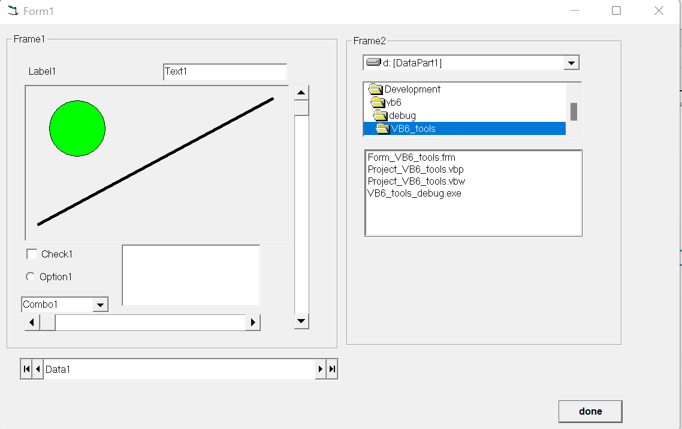

- VB5 legacy ocx tests This tests that the required VB5 legacy system files

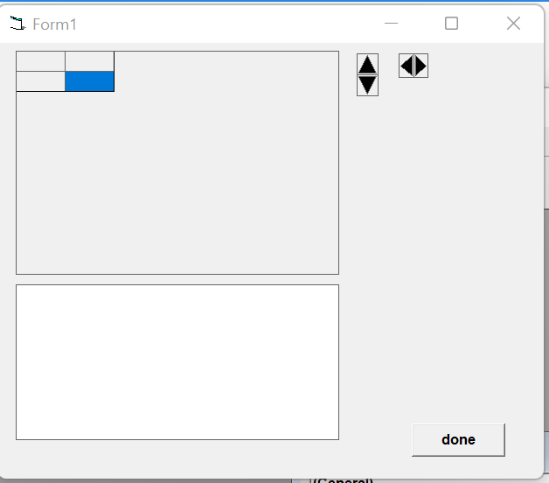

- VB6 redist ocx tests This tests that the required VB6 redistributable system files
